Bahria University,

Karachi Campus



COURSE: CEN 449, SYSTEM PROGRAMMING

TERM: FALL 2022, CLASS: BSE- 5(B)

Submitted By:

**M Muaz Shahzad 02-131202-081**

(Name) (Reg. No.)

Submitted To:

**Engr. M. RIZWAN FAZAL/Engr. M REHAN BAIG**

Signed Remarks: Score:

INDEX

|  |  |  |  |  |
| --- | --- | --- | --- | --- |
| SNO | DATE | LAB NO | LAB OBJECTIVE | SIGN |
|  |  |  |  |  |
|  |  |  |  |  |
|  |  |  |  |  |
|  |  |  |  |  |
|  |  |  |  |  |
|  |  |  |  |  |
|  |  |  |  |  |
|  |  |  |  |  |
|  |  |  |  |  |
|  |  |  |  |  |
|  |  |  |  |  |

Bahria University,

Karachi Campus



LAB EXPERIMENT NO.

**01**

LIST OF TASKS

|  |  |
| --- | --- |
| TASK NO | OBJECTIVE |
| 1 | **Write, Read and delete the text from file using Windows PowerShell ISE (Written text should be your name, department Name and your Enrollment Number)** |
| 2 | **Write scripts to copy the whole text from one file to other text file using Foreach Loop In Windows PowerShell ISE.** |
| 3 | **Write code that print the value of the day matches one of the numeric values using switch statement in power Shell ISE** |
|  |  |
|  |  |

Submitted On

**20/10/2022**

**Task 01: Write, Read and delete the text from file using Windows PowerShell ISE (Written text should be your name, department Name and your Enrollment Number)**

**Solution:**

$name=read-host -prompt "Enter your name:"

$department=read-host -prompt "Enter your Department"

$enrollment=read-host -prompt "Enter your Enrollment:"

$file = "C:\lab01.txt"

New-Item $file -ItemType file

try{

$writer=[System.IO.StreamWriter] $file

$writer.WriteLine("Name: "+$name)

$writer.WriteLine("Department: "+$department)

$writer.WriteLine("Enrollment: "+$enrollment)

$writer.Close()

Write-Host "File has been created`n"

}

catch{}

$x=1

while($x -eq 1){

$choice=Read-Host -Prompt("`nWhat do you want?`t1)Read Data`t2)Update Data`t3)Remove Content and Exit`nSelect: ")

if($choice -eq 1){

Write-Host "File Data"

Write-Host "=========="

Get-Content $file

}

elseif($choice -eq 2){

$data=Get-Content $file

$ch2=read-host -Prompt("`nWhat do you want to update?`t1)Name`t2)Department`t3)Enrollment`nSelect:")

if($ch2 -eq 1){

$name=read-host -prompt "Enter your name:"

$writer=[System.IO.StreamWriter] $file

$writer.WriteLine("Name: "+$name)

$writer.WriteLine($data[1])

$writer.WriteLine($data[2])

$writer.Close()

}

elseif($ch2 -eq 2){

$department=read-host -prompt "Enter your Department"

$writer=[System.IO.StreamWriter] $file

$writer.WriteLine($data[0])

$writer.WriteLine("Department: "+$department)

$writer.WriteLine($data[2])

$writer.Close()

}

elseif($ch2 -eq 3){

$enrollment=read-host -prompt "Enter your Enrollment:"

$writer=[System.IO.StreamWriter] $file

$writer.WriteLine($data[0])

$writer.WriteLine($data[1])

$writer.WriteLine("Enrollment: "+$enrollment)

$writer.Close()

}

Write-Host "`nFile Updated Successfully"

}

elseif($choice -eq 3)

{

Clear-Content $file

Write-Host "`nContent Removed Successfully"

break

}

}

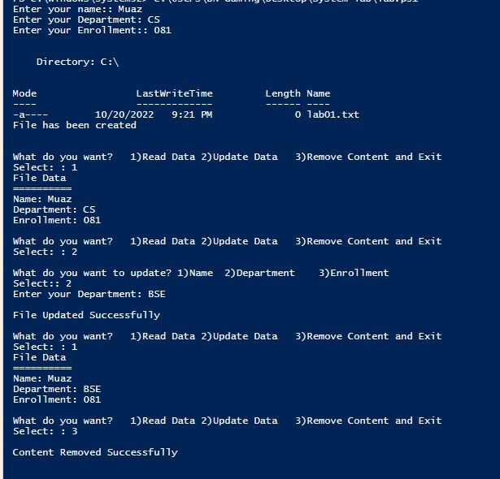**Output:**

**Task 02: Write scripts to copy the whole text from one file to other text file using Foreach Loop In Windows PowerShell ISE.**

**Solution:**

$file1 = "C:\Users\BN Gaming\Desktop\System lab\task.txt"

$file2 = "C:\Users\BN Gaming\Desktop\System lab\bukc1.txt"

New-Item $file2 -ItemType file

Write-Host "`nData of file 1"

Write-Host "=============="

Get-Content $file1

Write-Host "`nData of file 2"

Write-Host "=============="

Get-Content $file2

$data=Get-Content $file1

foreach($newData in $data ){

Add-Content $file2 $newData

}

Write-Host "`nData has been Copied"

Write-Host "`nData of file 2"

Write-Host "=============="

Get-Content $file2

**Output:**

**Task 03: Use the concept of Alerts in Bootstrap and provide the given output.**

**Solution:**

$select=read-host -Prompt("Select number:")

switch($select){

1 {"Saturday"}

2 {"Sunday"}

3 {"Monday"}

4 {"Tuesday"}

5 {"Wednesday"}

6 {"Thursday"}

7 {"Friday"}

}

**Output:**

